black book
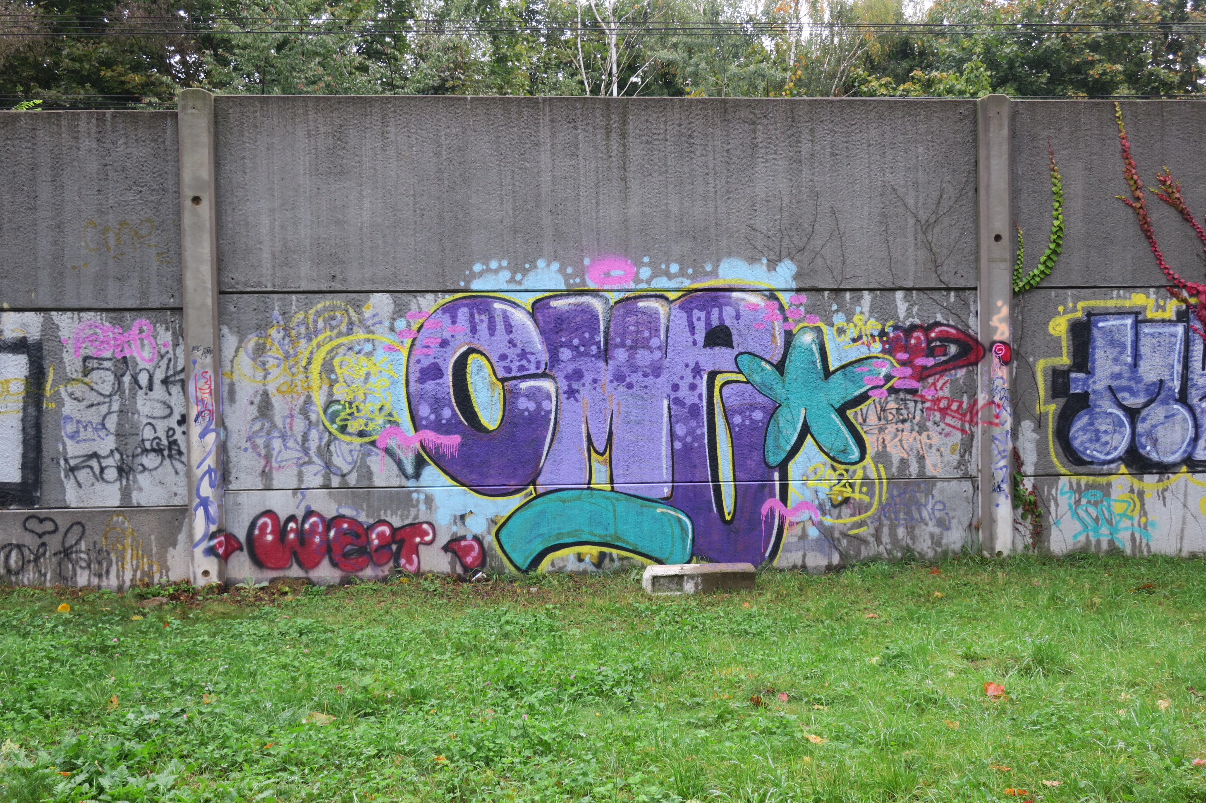A graffiti artist's sketchbook. Also known as a "piece book." It is often used to sketch out and plan potential graffiti, and to collect tags from other writers. It is a writer's most valuable property, containing all or a majority of the person's sketches and pieces.

blockbuster
A large graffiti with simple, legible letters. Often painted by a brush or a roller.

bomb
To bomb or hit is to paint many surfaces in an area. Bombers often choose to paint throw-ups or tags instead of complex pieces, as they can be executed more quickly.
crew
A crew, krew, or cru is a group of associated graffitists that often work together. Any group of friends can quickly and informally form a crew if they are interested in graffiti and want to start conspiring. Often crews will recruit new members over time in order to maintain their relevance. There is a smaller risk of being held responsible for crew works if a single member gets arrested. From a legal point of view, the name could have been painted by anyone in the group.

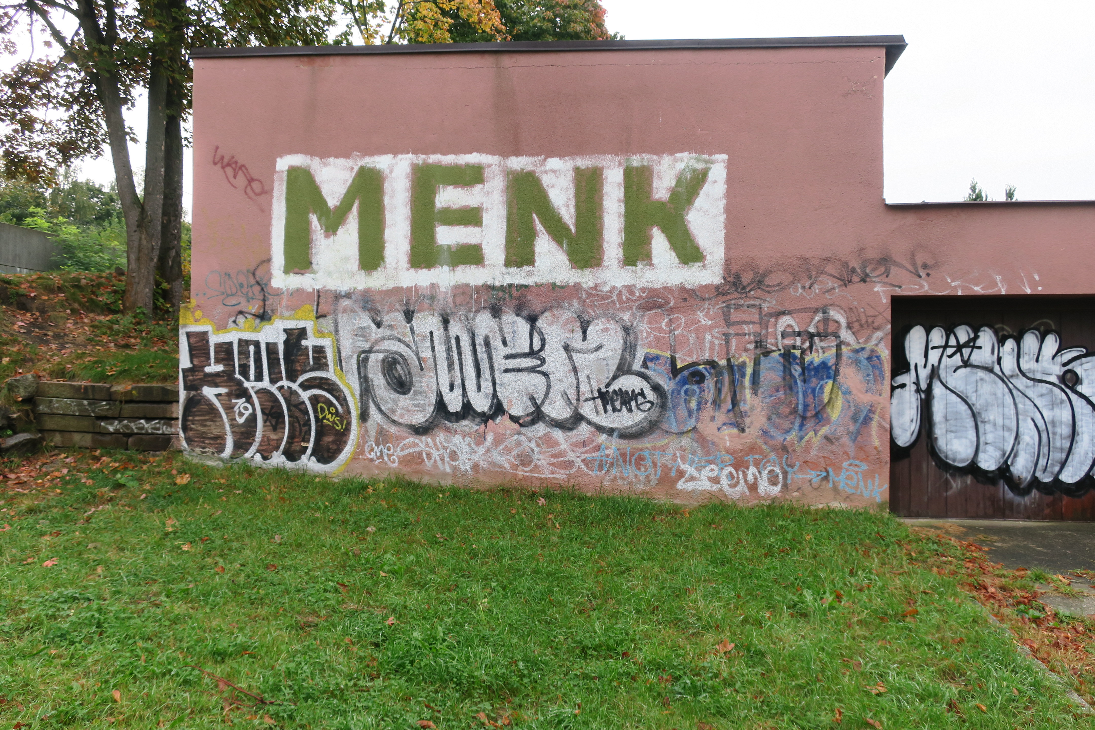going over
To "go over" a piece of graffiti simply means to paint on top of it. While most writers respect one another's artwork, to intentionally and disrespectfully paint on top of another's work is akin to a graffiti declaration of war. However (due partially to the limited amount of desirable wall-space) most graffiti writers maintain a hierarchy of sorts; a tag can legitimately be covered by a throw-up, and a throw-up by a piece, and this is commonly done without incident.

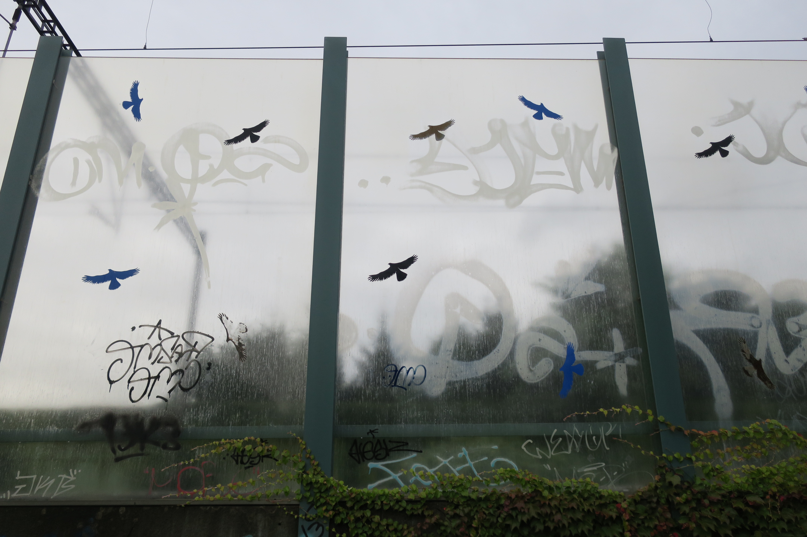heavens
Spots that are challenging to graffiti but in highly visible locations with heavy exposure. Billboards, freeway signs, and tall bridges are potential examples. This term also encompasses a double-meaning as the locations are often very dangerous to paint there and it may lead to death, thus, going to heaven (also known as "hitting up the heavens").

legal
A graffiti piece or production that is made with permission.
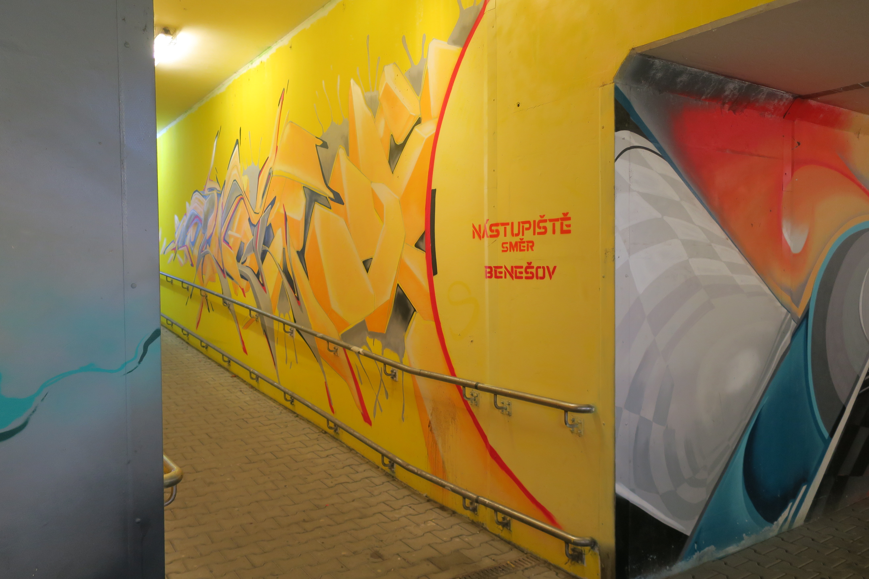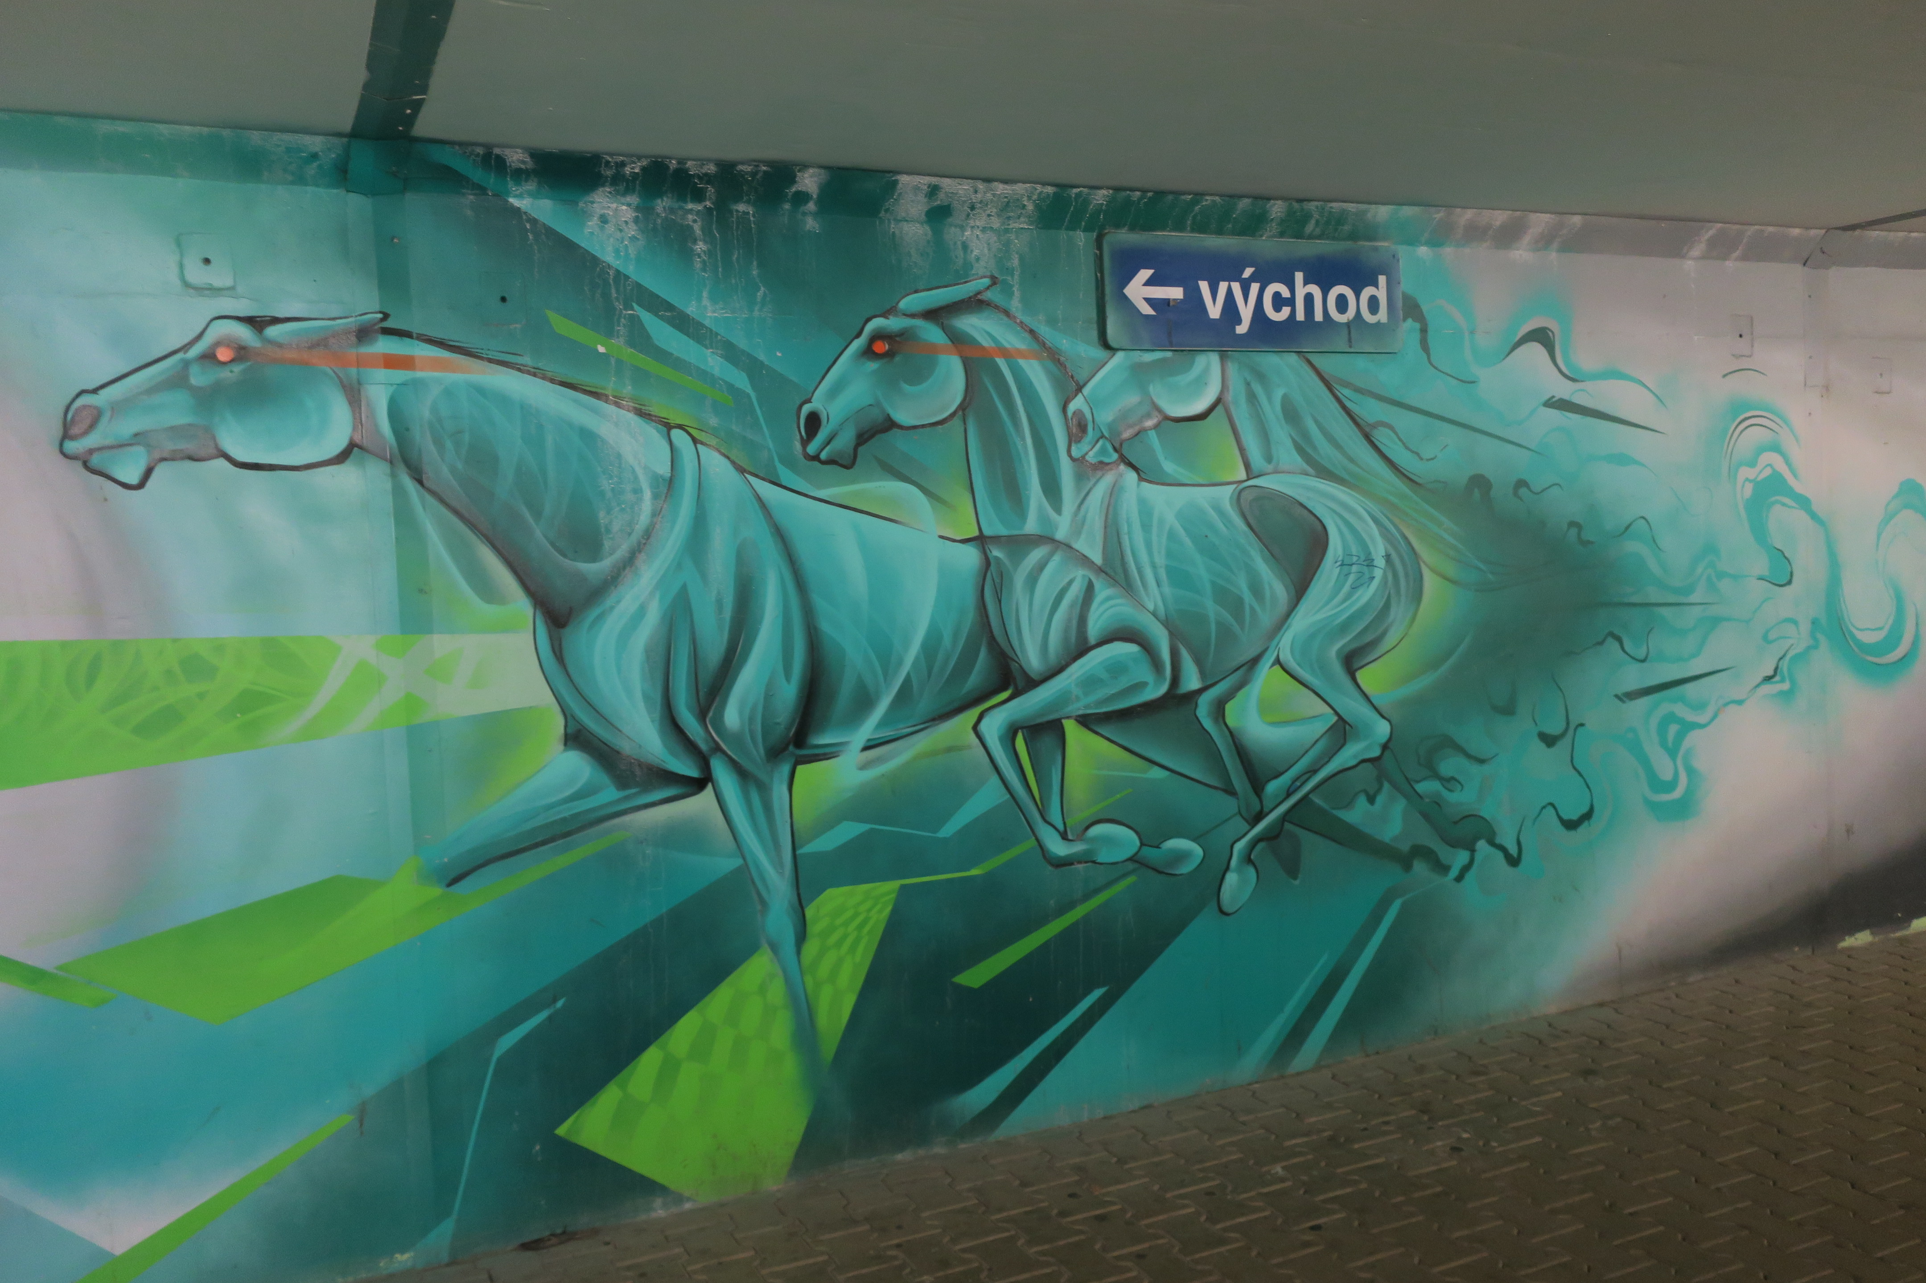

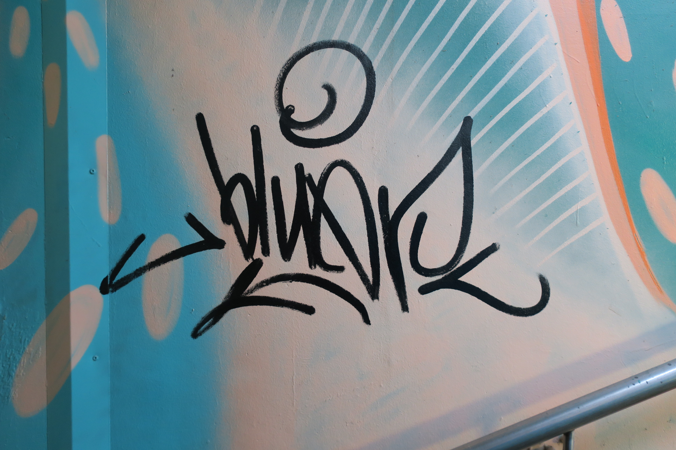
one-liner
A tag, throwie, or bomb written in one constant motion. These may be done with any writing utensil. The tip or nozzle of the writing implement does not lift from the canvas until the tag is complete.

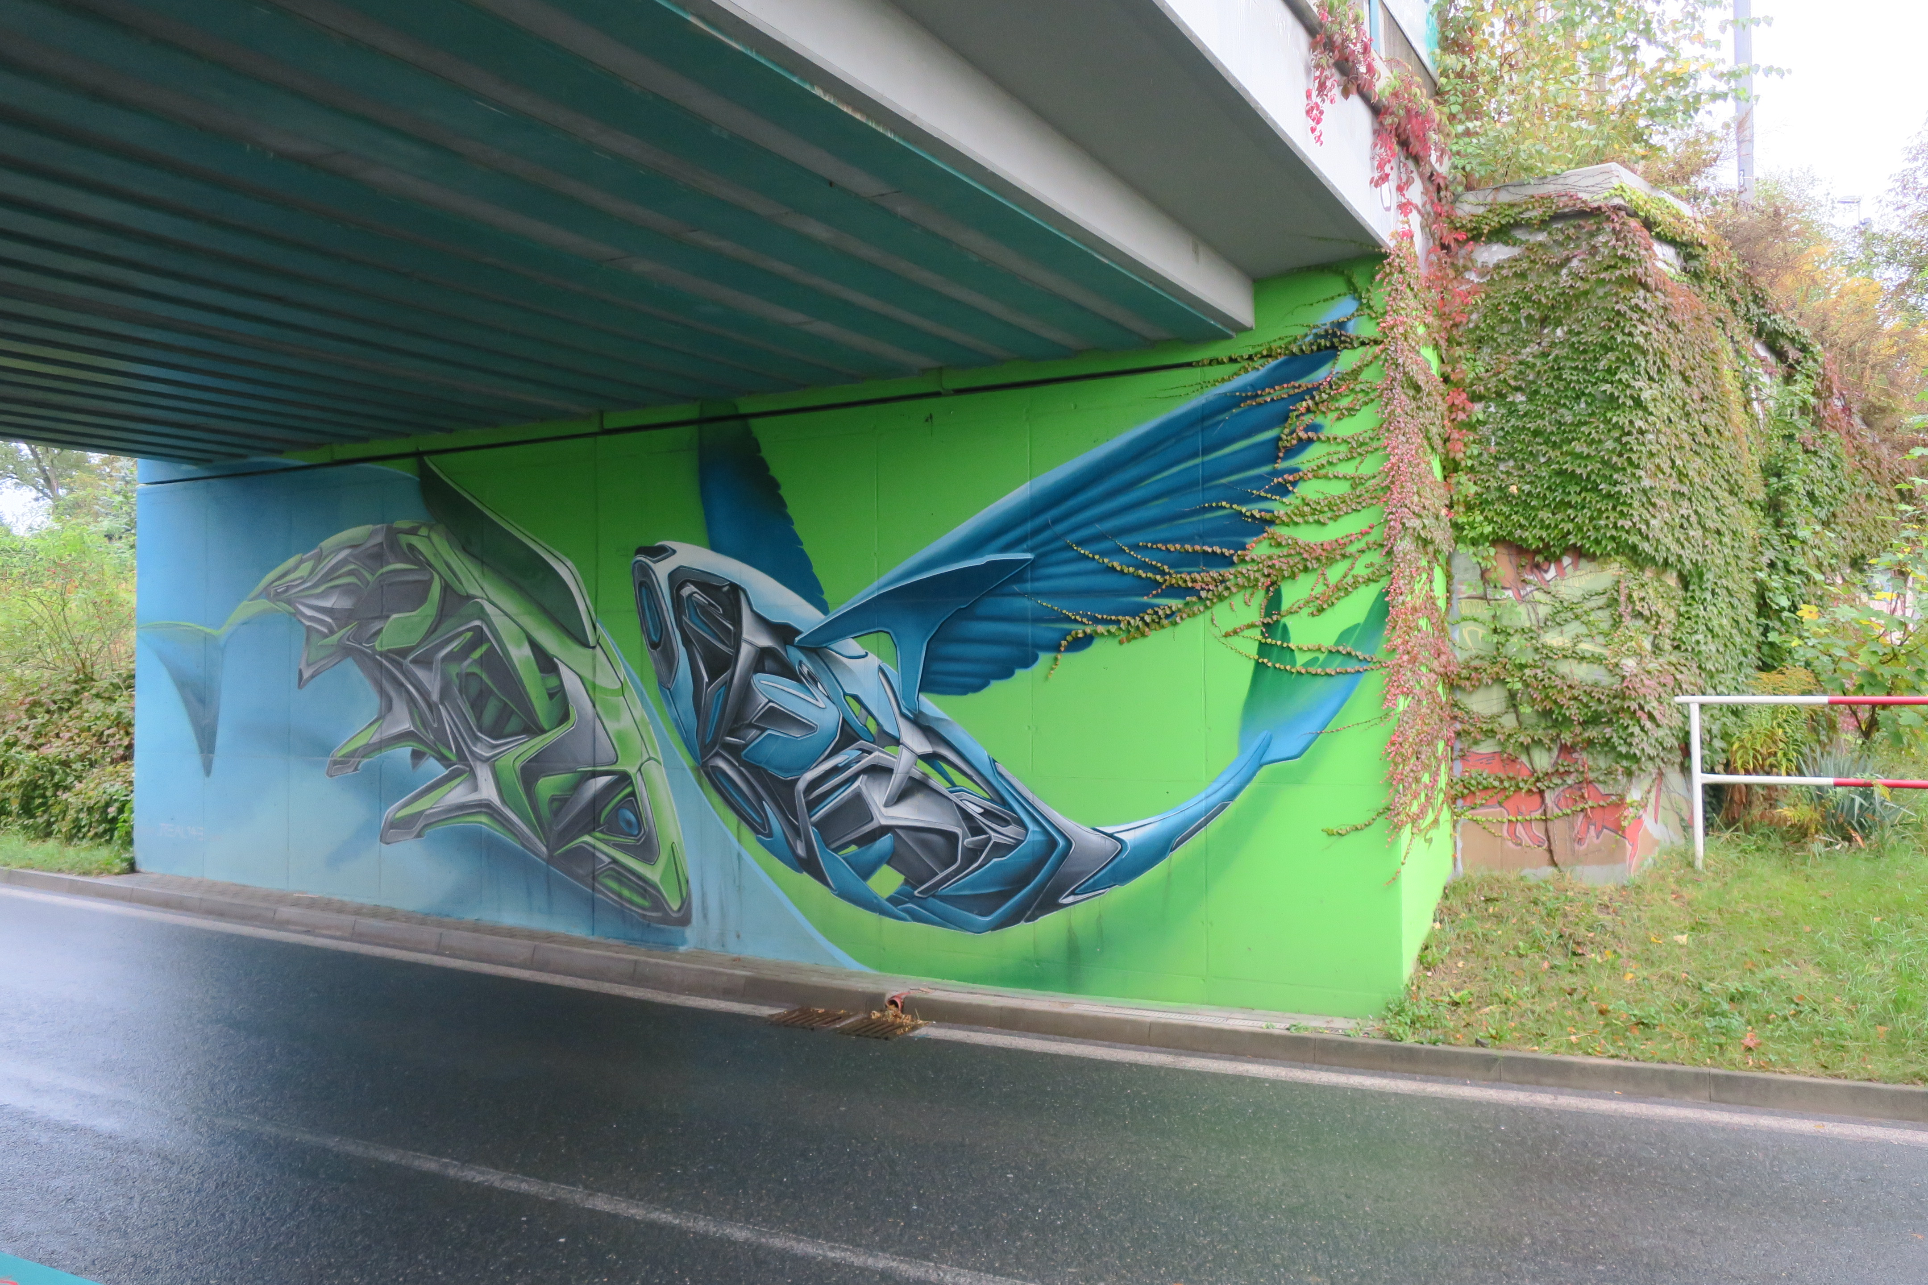piece (short form of masterpiece)
A large, complex, and labor-intensive graffiti painting. Pieces often incorporate 3-D effects, arrows, and many colors and color-transitions, as well as various other effects. These will usually be done by writers with more experience.

slam
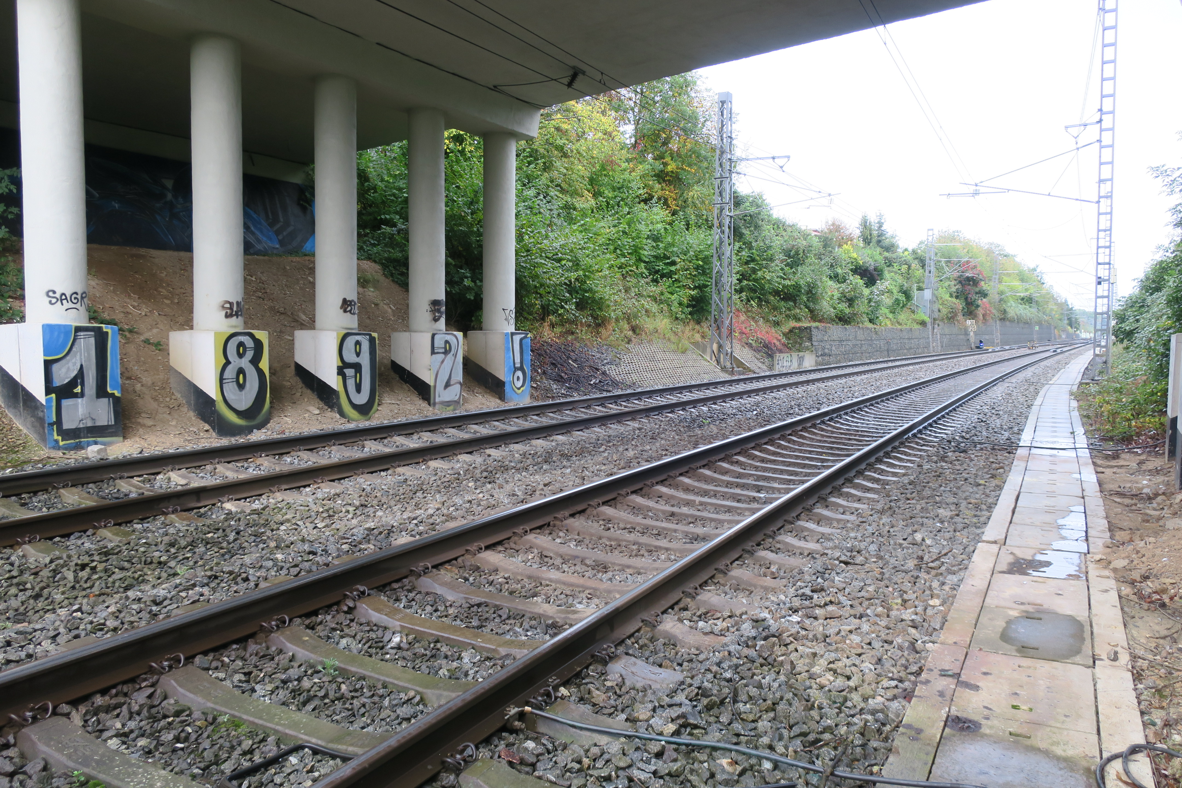To paint an extremely conspicuous or dangerous location.

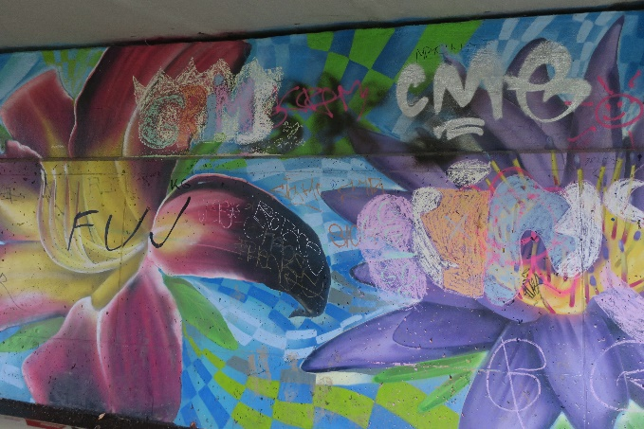
slash
To put a line through or tag over another writer's work. This generally happens for one of two reasons: either the individual being crossed out is considered to be lacking in style and/or originality to the point that another writer considers them an eyesore, or the crossing-out is part of an ongoing conflict between two or more writers (or crews).

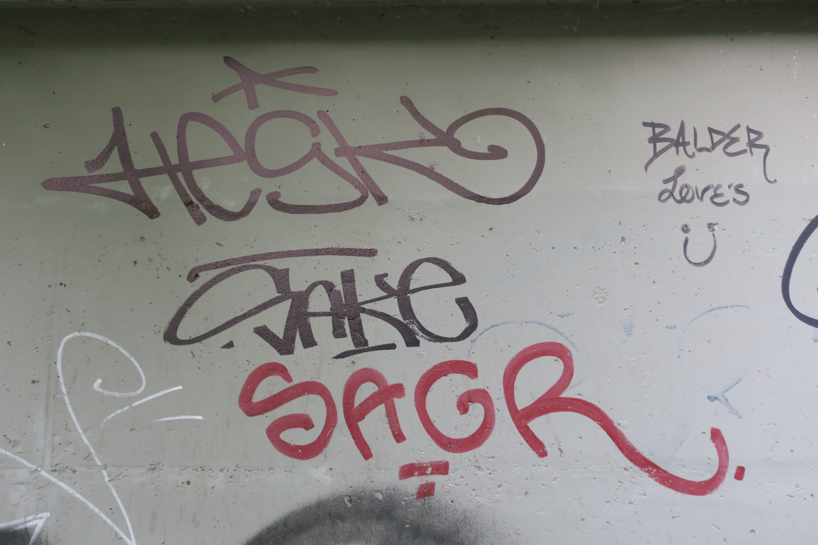tag
A stylized signature, normally done in one color. The simplest and most prevalent type of graffiti, a tag is often done in a color that contrasts sharply with its background. Tag can also be used as a verb meaning "to sign."
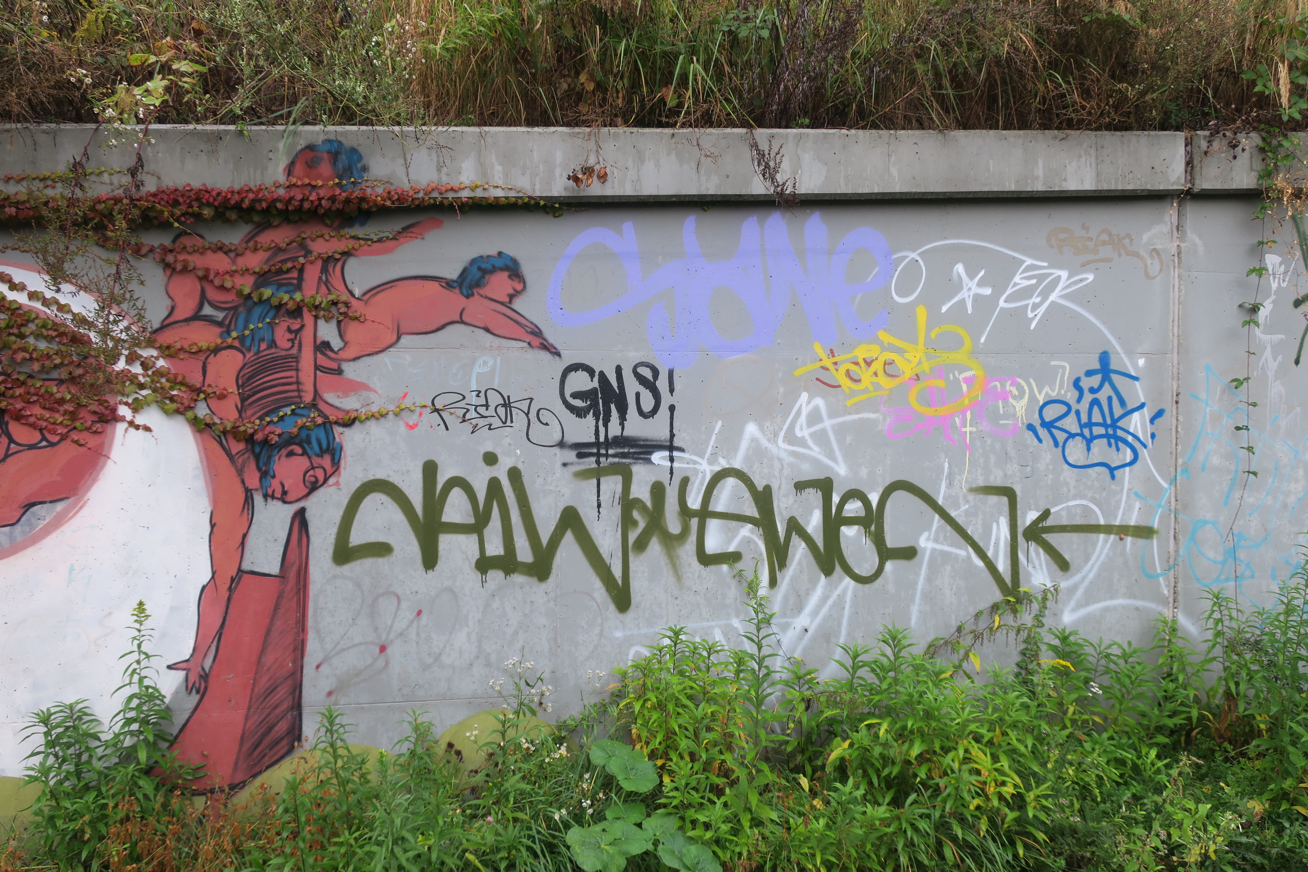

zdroj: https://en.wikipedia.org/wiki/Glossary_of_graffiti

